Zeppelin Raid

Night of 2nd/3rd September 1916

On the evening of Saturday the 2nd of September 1916 Germany launched the largest air raid of the Great War using a total of 16 airships. 14 aluminium-framed Zeppelins operated by the German Navy and 2 plywood-framed Schütte-Lanz craft operated by the German Army headed out across the North Sea to cross the English coast over East Anglia from where they then headed for targets in the North, the Eastern counties and London.
By mid-1916 England's defences against these air raids had been considerably strengthened since the first big raid a year earlier. Searchlights and anti-aircraft batteries now ringed London; the Royal Flying Corps was flying regular patrols above 10,000 feet and their aircraft were equipped with a recently developed ammunition for their Lewis guns - a mixture of three types of rounds designed specifically to puncture an airship's gas bags and then to ignite the released hydrogen gas.
The first of the airships heading for London that night, a German Army Schütte-Lanz airship, the SL-11, commanded by Wilhelm Schramm, arrived over St Albans at ten minutes past one in the morning of Sunday the 3rd of September. Schramm dropped bombs on the northern suburbs of London and while heading further south his airship was picked up by the searchlights at Finsbury Park and Victoria Park. Turning back to the north over Tottenham and Enfield, the SL-11 was spotted by Second Lieutenant William Leefe Robinson in his B.E.2c biplane. Leefe Robinson pursued and engaged the SL-11 and eventually with his third drum of ammunition succeeded in setting it on fire.
The descent of the blazing SL-11 from a height of two miles to a field at Cuffley was not only seen by many Londoners, but also by the Navy Zeppelins then making their approach. The L-16, commanded by Erich Sommerfeld was the nearest to the SL-11 when it burst into flames, and was seen by one of the RFC pilots who had been chasing SL-11. Sommerfeld headed off to the north, to escape the glow from SL-11 before the planes could arrive at his position. To speed this escape he jettisoned his bomb load as the L-16 was passing over Essendon and though many of the bombs fell on open land, others caused considerable damage to the church, and other buildings nearby. In one of these houses two daughters of the village blacksmith were mortally wounded.
Later that day thousands of sight-seers flocked to Cuffley hoping to see the wreckage of SL-11 which was quickly removed by the authorities. On Monday, the newspapers carried extensive reports which focussed largely on the shooting down of the SL-11 - a victory to be contrasted against the grim news from the battlefields of the Somme. "A Great Air Raid. One Zeppelin Destroyed. Wonderful Spectacle in London. Slight Casualties" was the heading to the leading article in The Times. That evening an inquest into the deaths of the 16 crew of SL-11 was held at the Plough Inn, Cuffley a short distance from the crash site. The coroner announced that the War Office had decided to give them a military funeral at the nearest cemetery and this took place two days later at Potters Bar cemetery.
On Tuesday, 5th, the country's delight in this first shooting down of a German airship on English soil was heightened when the King awarded the Victoria Cross to Leefe Robinson. Also, that day the inquest was held into the Essendon deaths and reported next day in The Times as follows:

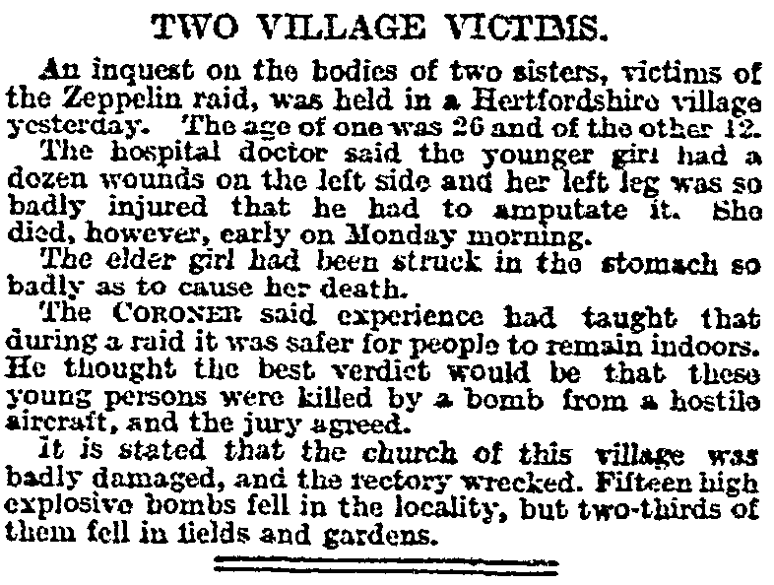

Frances and Eleanor Bamford were laid to rest in Essendon churchyard on the 6th of September. The Post Office staff magazine, the Telegraph & Telephone Journal, carried this obituary for Frances:
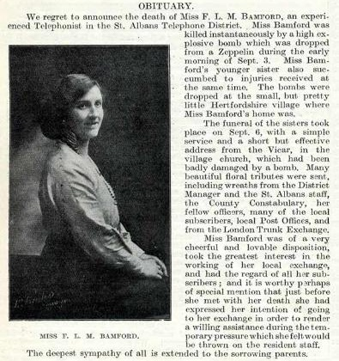

Reproduced with kind permission of BT Heritage & Archives
The bomb that hit the church came down on the flat roof of the vestry, flattening it, wrecking the organ, making a huge hole in the south wall of the chancel and shattering the roof above the altar. The east window was severely damaged, as were other windows in the church, but the nave, aisles and tower all withstood the blast. The church clock stopped at 23 minutes past two. Behind the rubble-strewn altar, the picture of "The Last Supper" was unharmed. Among the treasures destroyed in the vestry were the Baskerville Bible, presented to the church in 1791 by the Marquess of Salisbury, the remains of the old pulpit made in 1778, a table and two Chippendale chairs. The contents of the safe including the registers and church plate were undamaged.
The church insurance had been reviewed a short time before and confidence that the cost of repairs would be recovered allowed these to be set in motion quickly. The ruined parts of the church were restored close to their original state. Four stained glass windows were replaced by their original makers using the drawings kept from the 1883 rebuilding of the church and the Willis organ was rebuilt. A stone set in the south wall of the vestry commemorates the re-opening of the restored areas just one year later on Sunday, 2nd September 1917.

