St Mary, Ponsbourne

1858 Walker Pipe Organ
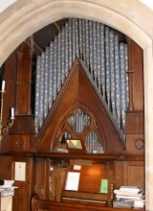
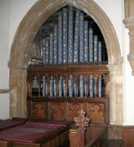
It is music which brings the church to life; and at the heart of our music-making is our pipe organ, made for the church by Joseph Walker in 1858. Already more than 150 years old, it was very worn and dirty, but historically and musically valuable. The organ was awarded a Historic Organ Certificate in 1999 by the British Institute of Organ Studies (BIOS), which states that it is "an instrument of importance to the national heritage".
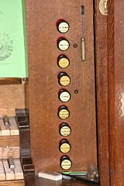
The instrument is sited in a chamber to the north-east of the church. It has two manual keyboards, each with 58 notes, and a pedal keyboard with 29 notes. Altogether, the organ has just over 700 speaking pipes, ranging in length from a few inches to 16 feet – and one of the longest pipes had to be made with a bend in it so that it would fit in the space available! On some organs, the decorated front pipes are just for show, but on this instrument most of them actually work. When originally installed in 1858, the console was in the arch from the organ chamber into the North Transept. On the building of a new Chancel in 1887 it was turned through 90 degrees into its present position and has served the parish since with only a few minor changes.
We needed to raise funds not only for the organ, but also to repair parts of the building nearby. (Note that the building work would itself raise dust, so ideally, we would have it done while the organ was dismantled, then clean the building before the organ was re-assembled on site.)
The parish is neither large nor rich, and we have sometimes struggled just to keep the doors open, hence the need to seek outside help. The total project cost has turned out to be approximately £130,000.

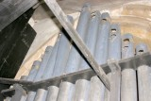
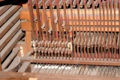
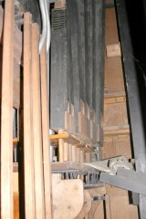
Brief History
• | 1849 | Church building completed and dedicated.
• | 1858 | Church spire added, and the present organ was built and installed by Joseph Walker, with the console facing into the North Transept (there was apparently a previous organ taken in part-exchange, but we know nothing about it).
• | 1867 | Organ converted to Equal Temperament
• | 1884 | Organ removed while chancel demolished and rebuilt, then re-installed (turned through 90 degrees from previous position) with the console now facing into the chancel.
• | 1909 | Mixture stop changed for Gamba (probably because it is more suited to choral accompaniment)
• | 1965 | Repairs carried out, after water damage to instrument
• | 1976 | Pedalboard replaced (wood-worm attack)
• | 1994 | The original electric Blower, dating from about 1935, replaced by a newer, quieter unit; and the trunking feeding air into the organ improved.
• | 2007 | Console light replaced by new unit (made from oak which came from the old church gates)
• | 2008 | Pedal light changed for LED unit
• | 2013 | Full restoration by Mander Organs of London

How and when is the organ used?
- Church Services, accompanying choir and congregation week by week
- Weddings
- Funerals
- other "occasional offices"
- Available for use with School services
- Practice sessions for choir and organist
- Occasional concerts

What was the Plan for the Restoration?
- Engage one of the firms of Organ Builders who have tendered for the project.
- Dismantle the instrument and move it to the Organ Builder's workshop for cleaning and refurbishment.
- Arrange redecoration works in and around the organ chamber.
- Restore the instrument to something like its state in 1909.
- Reinstall and re-commission the instrument, now restored.

1858 Walker Pipe Organ Restoration
Although historically and musically valuable, the pipe organ, made by Joseph Walker in 1858, has been in poor condition for a number of years. The parish has had other demands on its resources, such as keeping the weather out and stopping the tower from collapsing but has also tried to build up an Organ Fund towards the day when the instrument could be restored properly. In due course the Fund was large enough that it was feasible to put together plans and costs.
In the autumn of 2012, the parish applied for a grant from the "Your Heritage" Lottery Fund, together with a Faculty from the Diocese of St.Albans, to allow restoration work on the organ and the parts of the church around it, to go ahead. The responses were received at the end of 2012, with just under £100,000 from the Fund, and the Faculty (roughly the equivalent of planning permission) from the Diocese.
The project involved not only arrangements for the restoration work, completed during 2013, but also for education and outreach events (a condition of the grant being received). For instance, we worked with three of the local schools and the Royal College of Organists to introduce pupils to the way the organ works, the sounds it makes, and something of its history and repertoire. We arranged for some of the pupils from the school next door to visit the organ-builders' works to see the restoration in progress and set up events with the specialist contractor Howell & Bellion, who worked on the display pipes, which provided an insight into how their decorations were restored.
The instrument was dismantled in early April 2013 and, apart from a few of the largest pipes, was removed to the premises of Mander Organs in east London to be restored. In the meantime, the blower motor was sent for overhaul, other cleaning and repair work inside and above the Organ Chamber was set in train, and even the console mirror was resprayed!
At one point, when most of the Organ Chamber work had been completed, a couple getting married were able to sign the registers in that area - a unique occasion for them and for the church!
It had been hoped that the instrument would be returned to site within three months or so, but it was found that additional work was needed, mainly on the Great soundboard. This added to the time taken, but improved the final result. A new pedalboard has been made, based on a period original. Better access for tuning and maintenance has been incorporated in the re-assembled instrument, as well as improvements in maintenance lighting inside, and high-efficiency lighting for the console. Having been re-assembled, the organ entered the "running-in" stage after which any necessary adjustment could be made to the action and voicing. This involved the organist playing the instrument for many hours - in mid-winter!
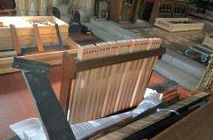 | 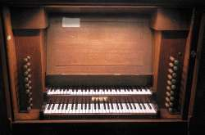
New Pedal Board | New Console Lighting
The Service of Re-dedication of the instrument took place on 26th January 2014 as part of a special Choral Evensong. The re-dedication ceremony was performed by the Dean of St.Albans, who also preached. This was followed by the Opening Recital on April 29th when the organ was played by Dr.William McVicker (the consultant for the project) and Mr. John Pike Mander contributed "Tales from a Tall Organ-Builder". Other events during 2014, in celebration of the restoration, included recitals by Andrew Parnell, Derek Harrison and Simon Williams.

The parish has always had a fine pipe organ. It has been restored just in time - before the bellows leather and some of the action failed and made it unplayable. In one respect, however, the instrument as it was lives on: A set of sample recordings of the sound of the instrument was made, pipe by pipe, before it was dismantled. A set of these recordings was passed to the organ builders, for reference. Another set was passed to an expert in the field (and long-time friend of the organist) who has processed them so that they can be played on an instrument of his own design. The results have been described in an article on his website and make interesting reading.

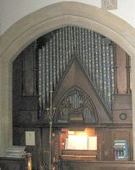 | Organ Chamber  before and after  removal of organ | 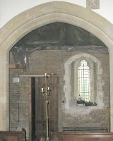

St.Mary's Ponsbourne Restoration Appeal
We continue to raise funds not only to ensure the organ can be maintained in the future, but also for the maintenance and improvement of the building.
Having got the building reasonably weather-proof, and restored the pipe organ, the next priority in today's world includes the provision of toilet facilities.
We also hope to make provision in due course, for a meeting room with a small kitchen.

Can I help, and how?
If in the area, provide practical support for fundraising events.
Provide donations to increase available funds (and, if a UK tax-payer, make use of Gift Aid declarations to help us at no cost to yourself)
Pass the word to others and encourage them to help us also.

